Using GitHub

1. First, you will need to sign up for an account on GitHub.com.
2. Install Git for Windows, Mac or Linux as needed: <https://git-scm.com/downloads>
3. Install the Git Bash app you just installed using your OS terminal. Enter the following commands:

git config --global user.name "Your Name Here"

git config --global user.email "your_email@youremail.com"

1. Create a new repository online:

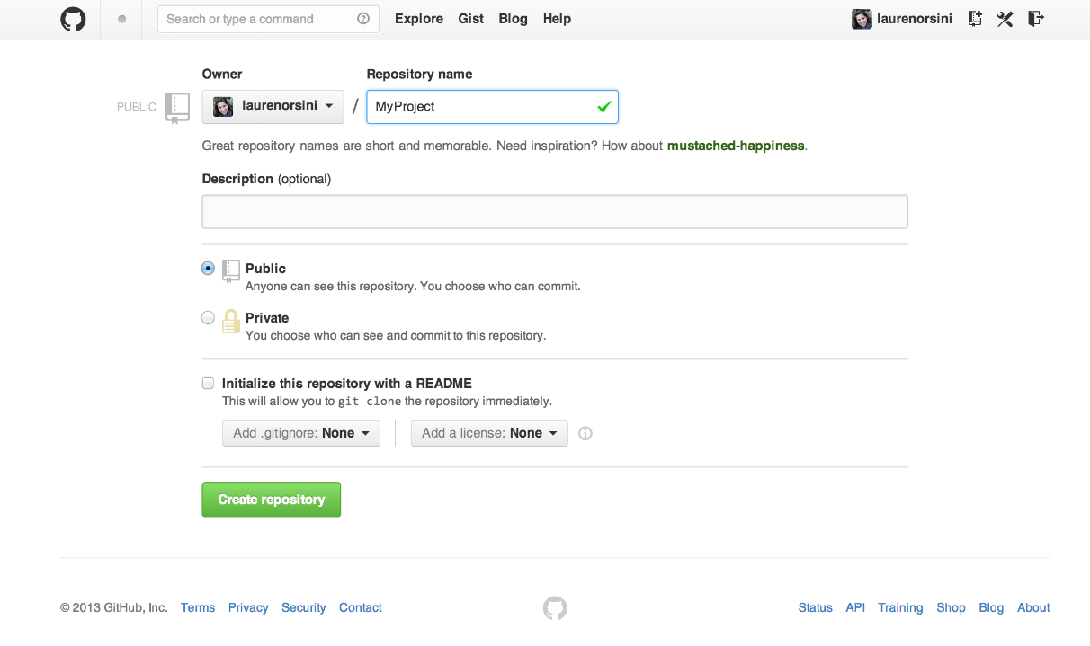

1. Create your local repository on your computer. Enter the following commands:

mkdir MyProject

cd MyProject

git init

1. Connect your local repository to your GitHub repository. Enter the following commands:

git remote add origin https://github.com/username/myproject.git

1. To confirm, type this to check:

git remote -v

1. To upload or “push” a new update to the GitHub remote repository, enter the following command:

git push

1. *Optional*: If you want to specify the branch of your repository, enter the following:

git push origin master